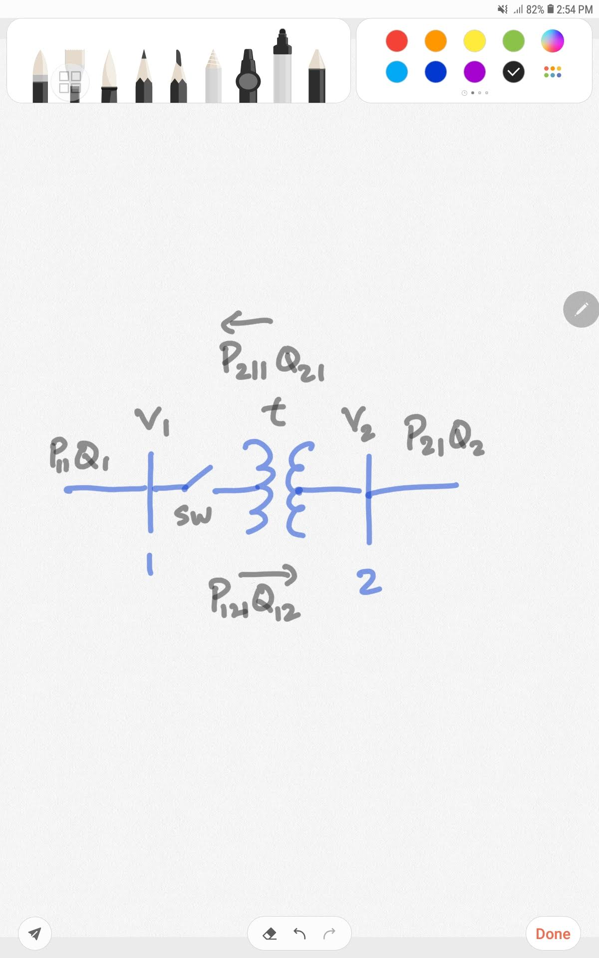

|  |  |  |  |  |  |  |  |  |  |  |  |  |
| --- | --- | --- | --- | --- | --- | --- | --- | --- | --- | --- | --- | --- |
|  | V1 | V2 | SW | t | P1 | Q1 | P2 | Q2 | P12 | Q12 | P21 | Q21 |
| Normal scenario | 0.9703 | 0.9877 | 1 | 1.05 | -0.0226 | 0.0358 | 0.0071 | 0.0358 | 2.4487 | 0.9709 | -2.4277 | -0.7417 |
| Attack demo  (Not stealthy) | 1.0587 | 0.9837 | 1 | 0.9 | 0.0055 | -0.0106 | -0.0076 | 0.0142 | 2.4588 | -0.4022 | -2.4549 | 0.6642 |
| Stealthy attack modifications | 0.0878 | 0.9837 | 1 | 0.15 | 0.2781 | 0.2694 | -0.1606 | -1.6322 | 0.1606 | 1.6848 | -0.1606 | -1.6322 |
| Evasive Measure |  |  |  |  |  |  |  |  |  |  |  |  |

Normal conditions : Detection metric reads 0.06

Attack : Detection metric reads 2.73

Relationship between Tap and detection

**How to calculate?**

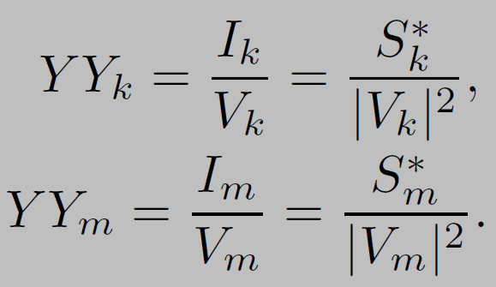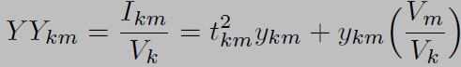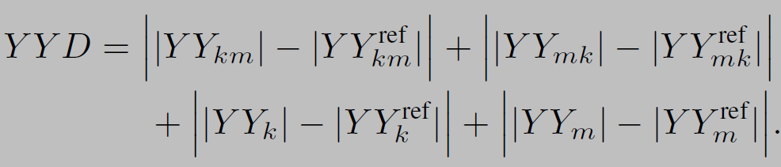

EMS

SUBSTATION

**YYD = function (Measurements) = function (states)m**

**Where,**

Relationship between power generation and load

|  |  |  |  |  |
| --- | --- | --- | --- | --- |
| Number of load | Voltage (kV) | Frequency (Hz) | Motor speed (High Low Stop) | Pump Speed (High Low Stop) |
| 0 |  |  |  |  |
| 1 |  |  |  |  |
| 2 |  |  |  |  |
| 3 |  |  |  |  |
| 4 |  |  |  |  |
| 5 |  |  |  |  |
| 6 |  |  |  |  |

Load:

1. Residential
2. City
3. Runway
4. Station
5. Inner track
6. Outer Track